# INTRODUCTION

* 1. Poject Overview:

In this project, we created Property Management for Using Salesforce and that helps the reports of various sales for Building properties as well as.

We created a application, they are

* Property Management.
* The Property Management app helps to store the records of sales for building properties.

# 2.Problem Definition and Design Thinking

2.1 Empathy map:

 2.2 Ideation and Brainstorming map:

# 

# Result

3.1 Data Model:

|  |  |  |
| --- | --- | --- |
| **Object Name** | **Field Label** | **Data type** |
| Buy | City  State  Discount  Property type | Picklist  Picklist  Percent  Picklist |
| Rent | Rent  Rental city  BHK type | Auto Number  Text  Picklist |
| Loan | Loan id  Inetrest rate  Term  Annual loan  Total Loan installments  Loan Repayment  Loan Amount  Loan object | Auto number  Currency  Number  Number  Number  Number  Formula  Formula |

3.2 Activity and screen shots

Milestone 1:

Creating Developer Account

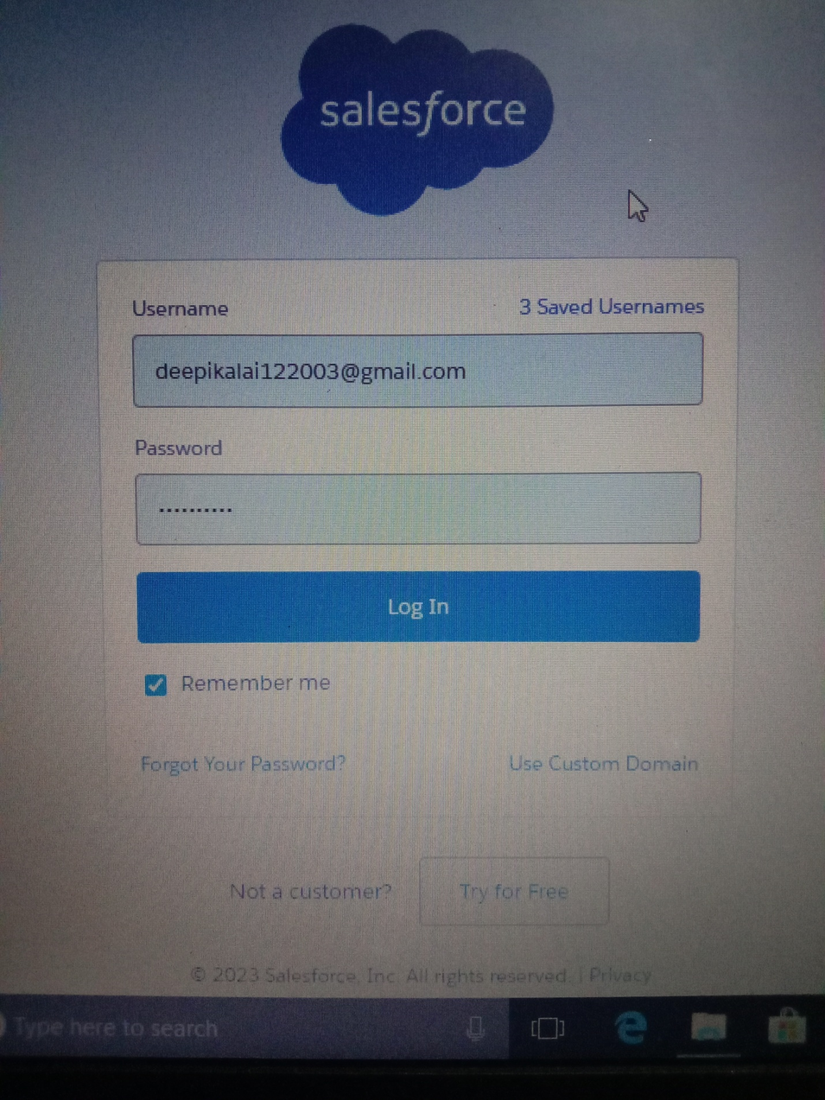

Milestone 2:

Activity 1- creation of object Buy, Rent & Loan.

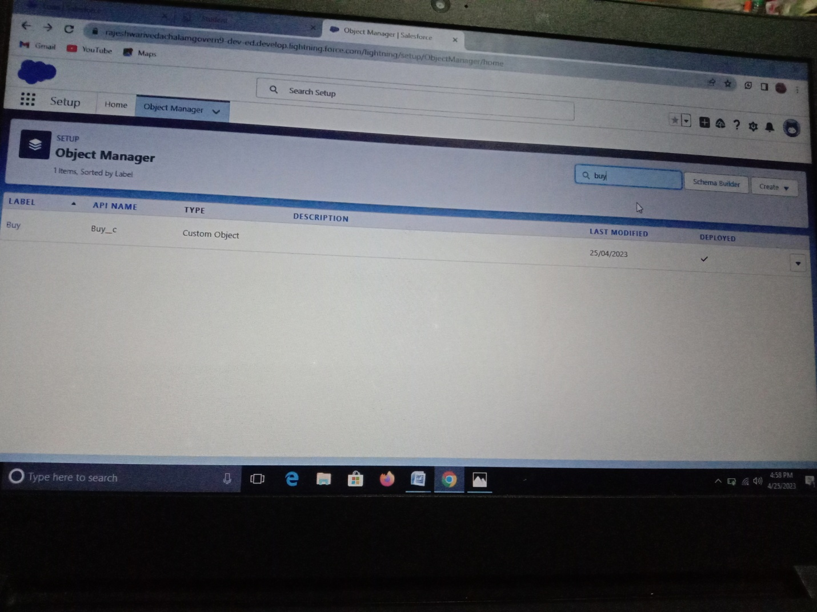

Milestone 3: Creation of Lightning App for Property Management:

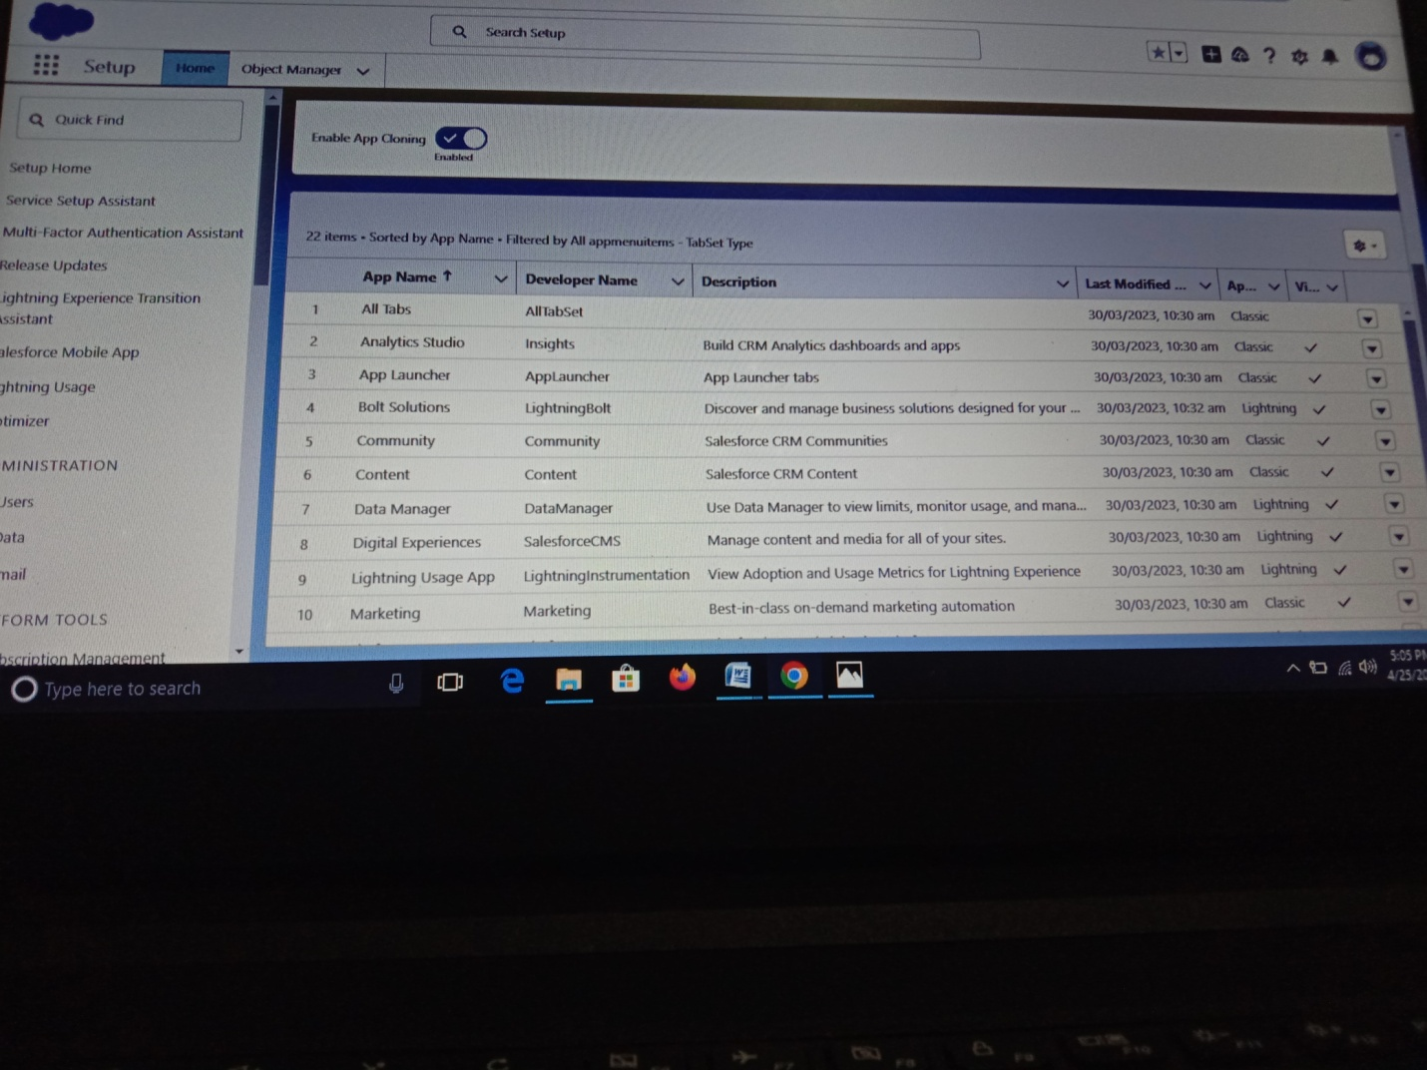

Milestone 4: Creation the fields for Buy, Rent & Loan Object:

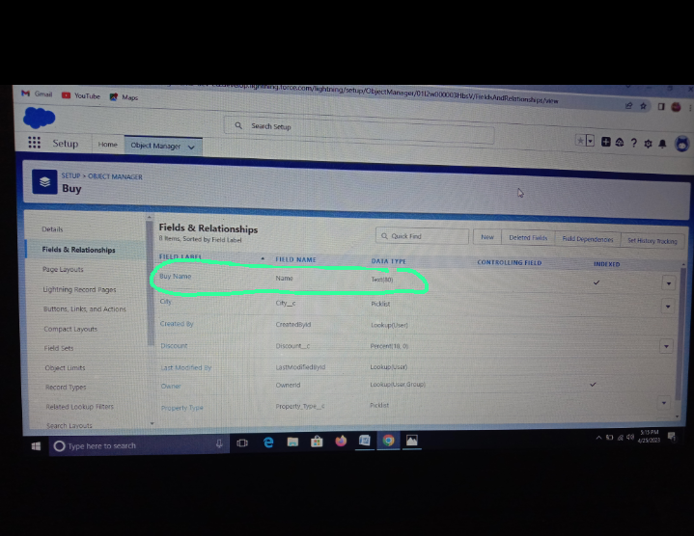

Milestone 5: Creation of Profile:

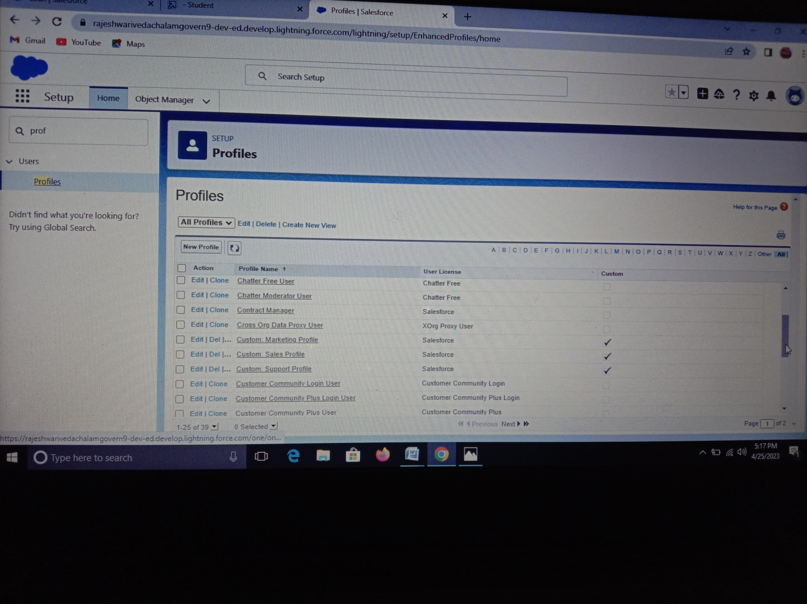

Milestone 6: Creation of User:

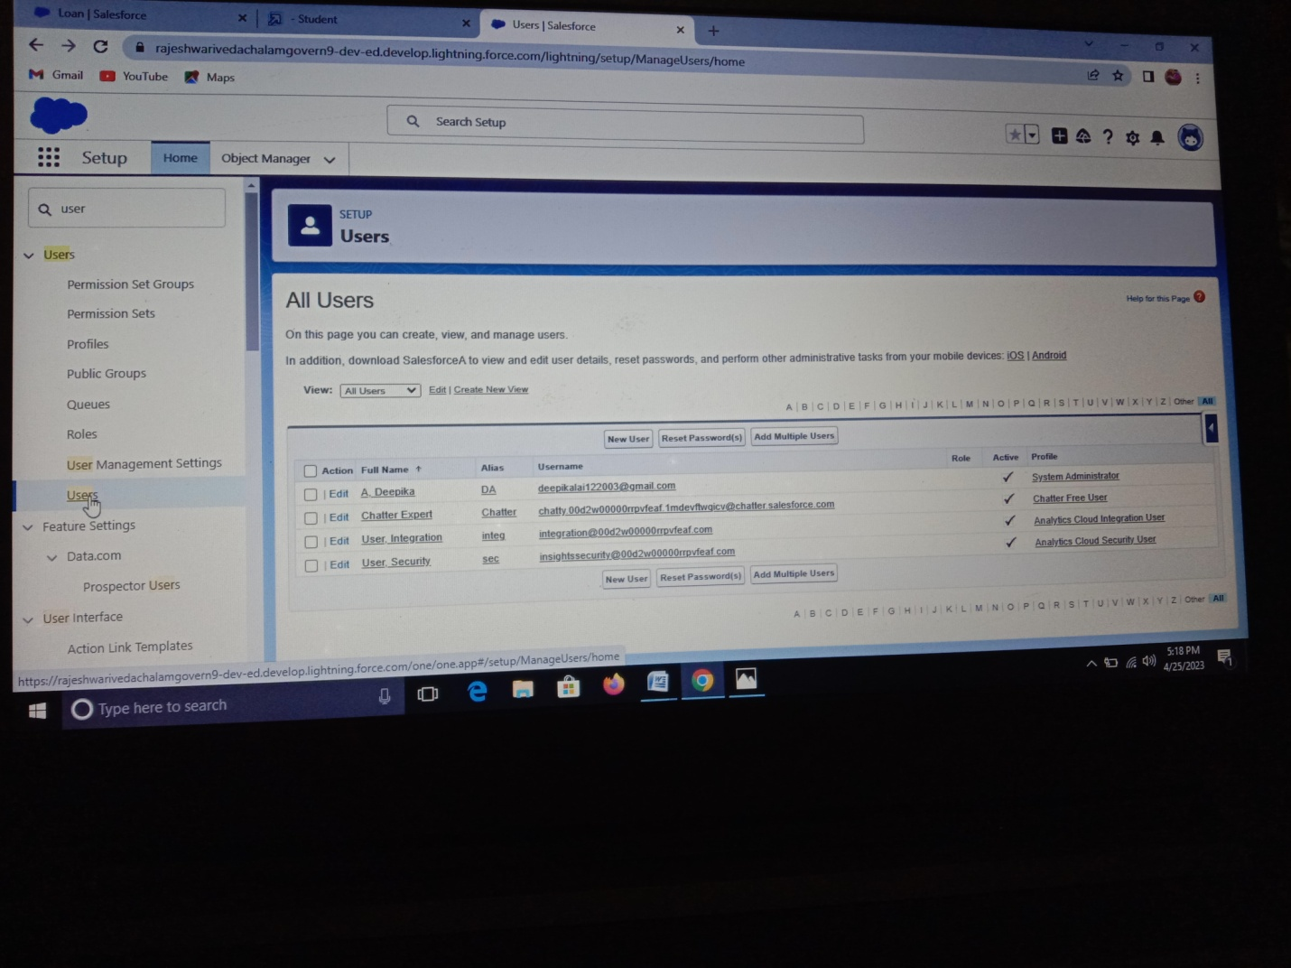

Milestone 7: Creation of Permission Sets:

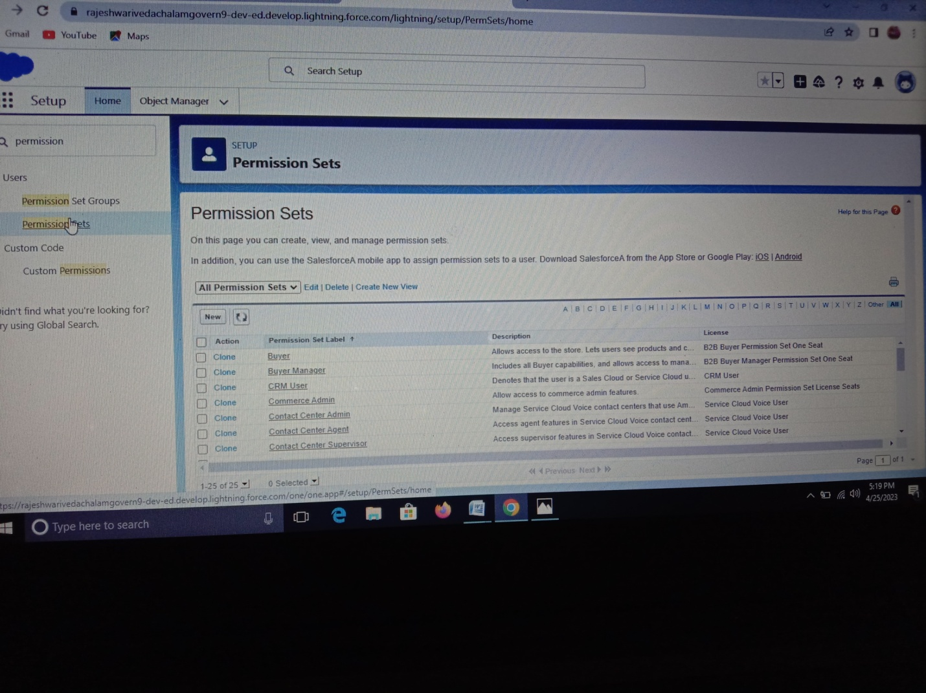

Milestone 8: Creation of Reports:

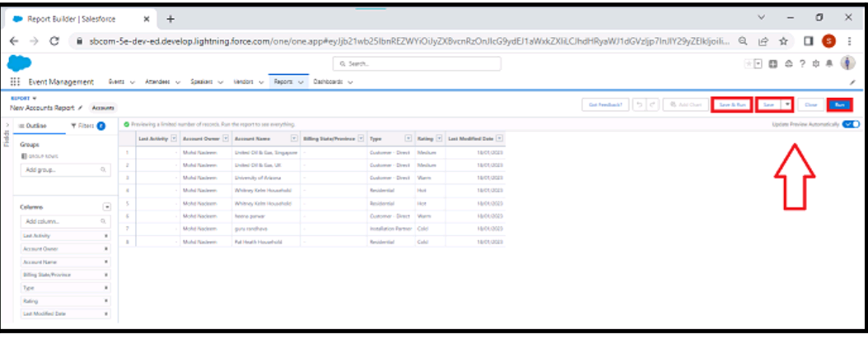

# Trailhead Profile Public URL:

Team leader: https://trailblazer.me/id/deepa1742

Team member 1: https://trailblazer.me/id/demin6

Team member 2: http://trailblazer.me/id/jayas390

Team member 3: https://trailblazer.me/id/dkeerthana10

# Advantages and Disadvantages:

In this Salesforce we are prepare a Property Management App for Sales for Building Properties. And it is very useful to easily take over the Level of Selling Houses and also give Discounts, Gifts., etc…..

# Application:

Our Apps is to be:

* All kinds of Property Management,
* All type of Report Collecting Companies,
* Etc…..

# Conclusion:

We are create the objects with the help of Selling Houses and Apartments with the help of Salesforce App . And also create App (Property Management) with the help of Salesforce . And then the objects are converted to Fields and then Permission sets. Atlast finished the creation of App.

# Future Scope:

Ability to create a App.